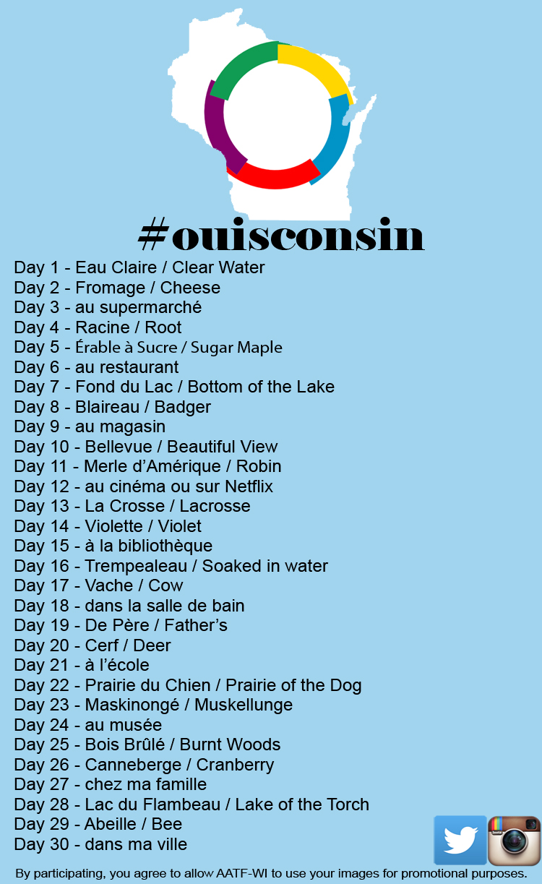
Student Instructions
- Every day in November post a picture to twitter or Instagram to
complete the challenge.

- For each day use the hashtag #ouisconsin.
- For each day, use the hashtag of the day’s theme in French. For days when the theme is multiple words, condense them into one hashtag. For example, Day 18 would have the hashtag #danslasalledebain.
- Each day should have two hashtags, for example Day 1 would have the hashtags #ouisconsin #eauclaire
- Your teacher may ask you to add a third hashtag to identify you as a student at your school; write that hashtag here: #_______________
- Days 3, 6, 9, 12, 15, 18, 21, 24, 27, and 30 should be original pictures that you take.
- For the other days, if you cannot take a picture related to the theme, you may find an image on the internet related to the theme.
- You may use pictures of the literal translation. For example, for Day 1 you may use a picture of clear water instead of the city of Eau Claire.
- Make sure that your privacy settings are set to public, otherwise your submissions cannot be viewed by your teacher or AATF-WI.
- By participating in this picture scavenger hunt, you agree to allow AATF-WI to use your images for promotional purposes.

